Docker Lab Exercise: Build, Tag & Push 5 Images
🔧 Lab Objectives
- Create Dockerfiles using different base images
- Use key Dockerfile instructions (FROM, ENV, RUN, COPY, EXPOSE, WORKDIR, VOLUME, CMD, ENTRYPOINT)
- Build and tag images
- Push to Docker Hub
- Create containers with port and volume mappings

📁 Setup
mkdir docker-lab
cd docker-lab
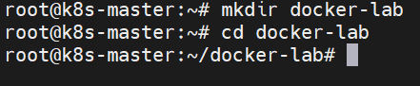

🧩 Dockerfile 1 – Ubuntu with Apache
File: Dockerfile.ubuntu-apache
FROM ubuntu:22.04
ENV DEBIAN_FRONTEND=noninteractive
RUN apt update && apt install -y apache2
WORKDIR /var/www/html
COPY index.html .
EXPOSE 80
VOLUME ["/var/www/html"]
CMD ["apache2ctl", "-D", "FOREGROUND"]
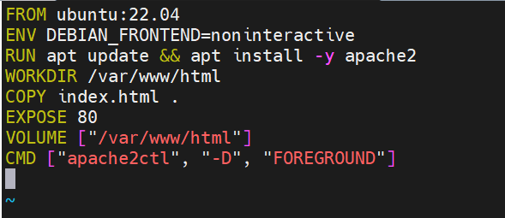
Vi index.html
<html><body><h1>Ubuntu Apache Server</h1></body></html>
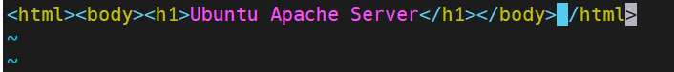
Build & Run
docker build -f Dockerfile.ubuntu-apache -t ubuntu-apache:v1 .
docker tag ubuntu-apache:v1 your_dockerhub_username/ubuntu-apache:v1
docker login
docker push your_dockerhub_username/ubuntu-apache:v1
docker run -d -p 8080:80 --name ubuntu-apache ubuntu-apache:v1
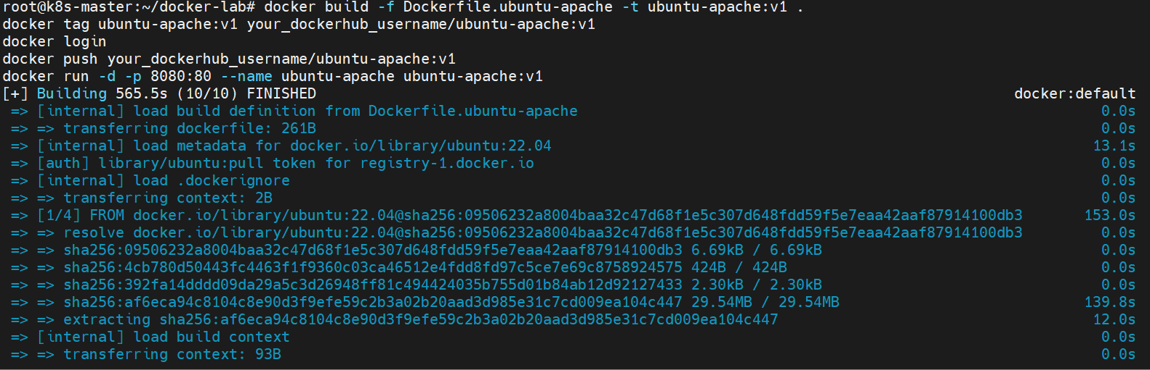

🧩 Dockerfile 2 – CentOS Stream 10 with httpd
File: Dockerfile.centos-httpd
FROM quay.io/centos/centos:stream10
RUN dnf install -y httpd && dnf clean all
COPY index.html /var/www/html/
WORKDIR /var/www/html
EXPOSE 80
VOLUME ["/var/www/html"]
CMD ["/usr/sbin/httpd", "-D", "FOREGROUND"]
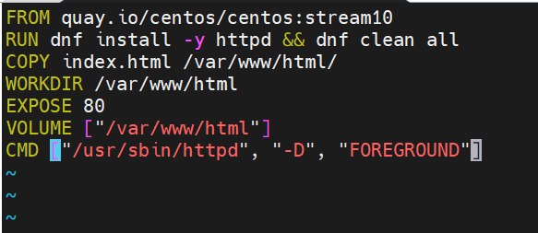
Vi index.html
<html><body><h1>CentOS Stream 10 HTTPD</h1></body></html>
Build & Run
docker build -f Dockerfile.centos-httpd -t centos-httpd:v1 .
docker tag centos-httpd:v1 your_dockerhub_username/centos-httpd:v1
docker push your_dockerhub_username/centos-httpd:v1
docker run -d -p 8081:80 --name centos-httpd centos-httpd:v1
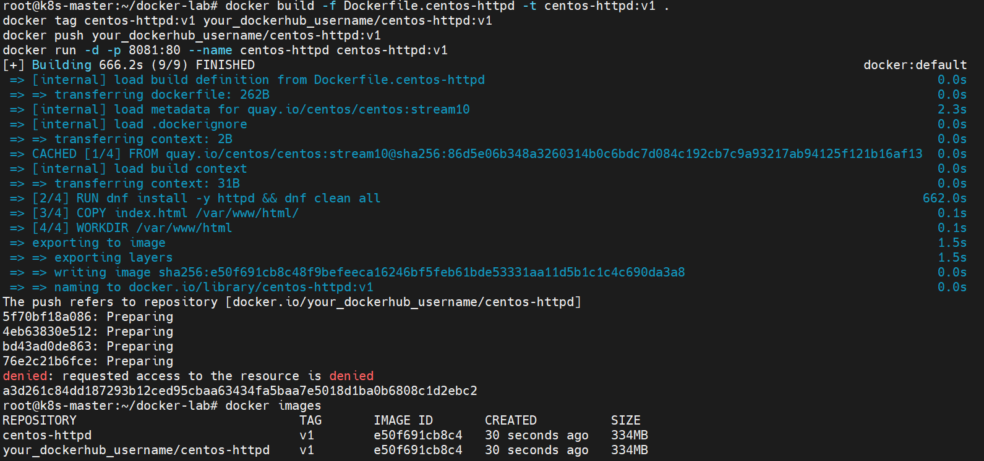

🧩 Dockerfile 3 – Nginx with custom homepage
File: Dockerfile.nginx
FROM nginx:latest
WORKDIR /usr/share/nginx/html
COPY index.html .
EXPOSE 80
VOLUME ["/usr/share/nginx/html"]
CMD ["nginx", "-g", "daemon off;"]
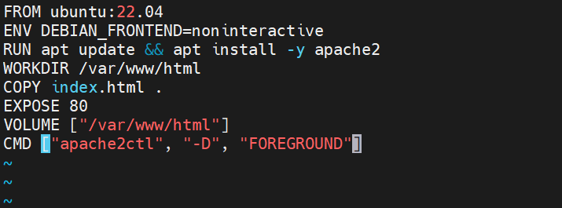
index.html
<html><body><h1>Custom NGINX Page</h1></body></html>
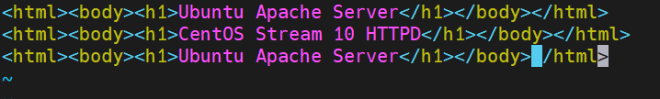
Build & Run
docker build -f Dockerfile.nginx -t custom-nginx:v1 .
docker tag custom-nginx:v1 your_dockerhub_username/custom-nginx:v1
docker push your_dockerhub_username/custom-nginx:v1
docker run -d -p 8082:80 --name custom-nginx custom-nginx:v1
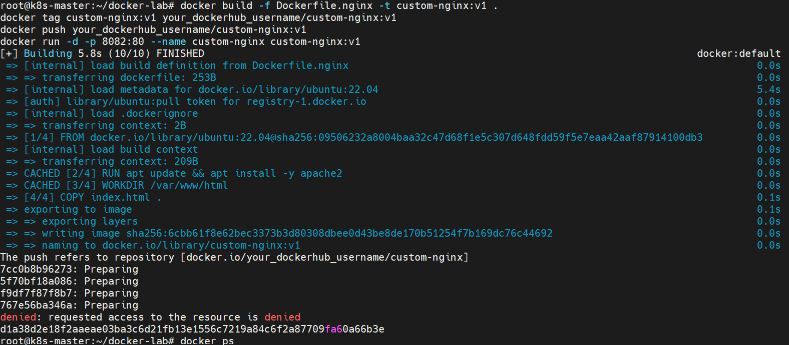

🧩 Dockerfile 4 – Python Flask App
File: Dockerfile.python-flask
FROM python:3.10-slim
ENV APP_HOME=/app
WORKDIR $APP_HOME
COPY app.py .
RUN pip install flask
EXPOSE 5000
CMD ["python", "app.py"]
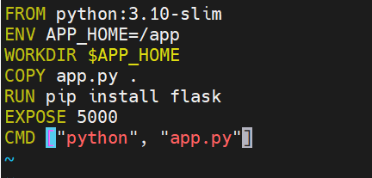
Vi app.py
from flask import Flask
app = Flask(__name__)

@app.route('/')
def home():
return "Hello from Flask running in Docker!"

if __name__ == "__main__":
app.run(host='0.0.0.0', port=5000)
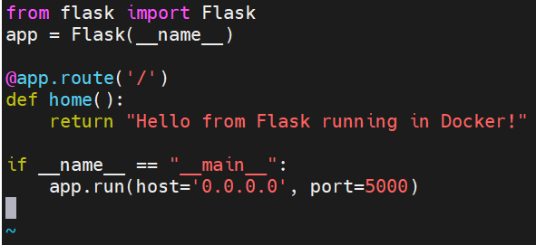
Build & Run
docker build -f Dockerfile.python-flask -t python-flask:v1 .
docker tag python-flask:v1 your_dockerhub_username/python-flask:v1
docker push your_dockerhub_username/python-flask:v1
docker run -d -p 5000:5000 --name flask-app python-flask:v1
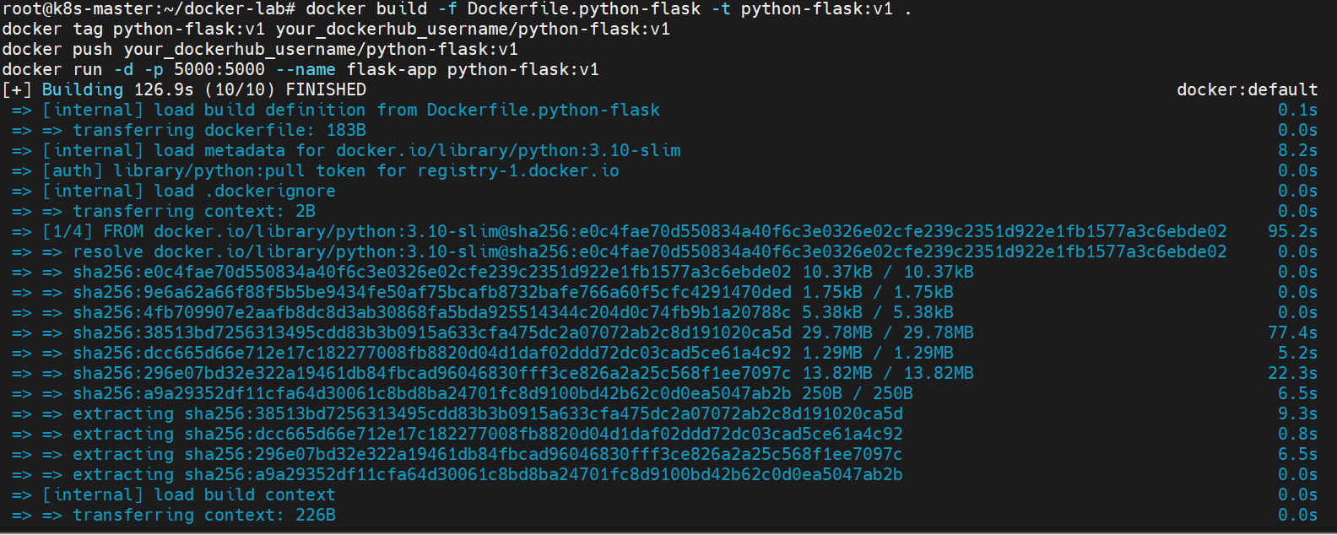

🧩 Dockerfile 5 – Alpine Custom Script
File: Dockerfile.alpine-script
FROM alpine:latest
WORKDIR /usr/local/bin
COPY hello.sh .
RUN chmod +x hello.sh
ENTRYPOINT ["./hello.sh"]
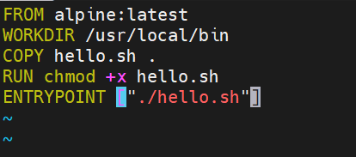
Vi hello.sh
#!/bin/sh
echo "Hello from Alpine custom container!"
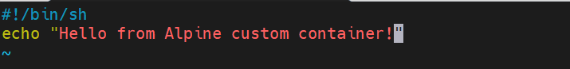
Build & Run
docker build -f Dockerfile.alpine-script -t alpine-script:v1 .
docker tag alpine-script:v1 your_dockerhub_username/alpine-script:v1
docker push your_dockerhub_username/alpine-script:v1
docker run --name alpine-hello alpine-script:v1
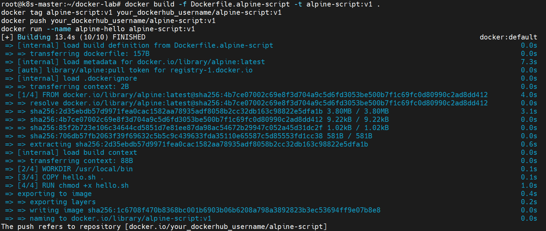

🧹 Cleanup Commands
docker stop $(docker ps -q)
docker rm $(docker ps -aq)
docker rmi $(docker images -q)

✅ Validation Tasks
- List images and tags:
docker images
- List running containers:
docker ps
- Access web containers from browser:
  - Ubuntu Apache → http://localhost:8080
  - CentOS HTTPD → http://localhost:8081
  - Nginx → http://localhost:8082
- Verify Flask:
curl http://localhost:5000
- Check Alpine output:
docker logs alpine-hello

